ACCESS QUERIES

PRODUCT TABEL SQL VIEW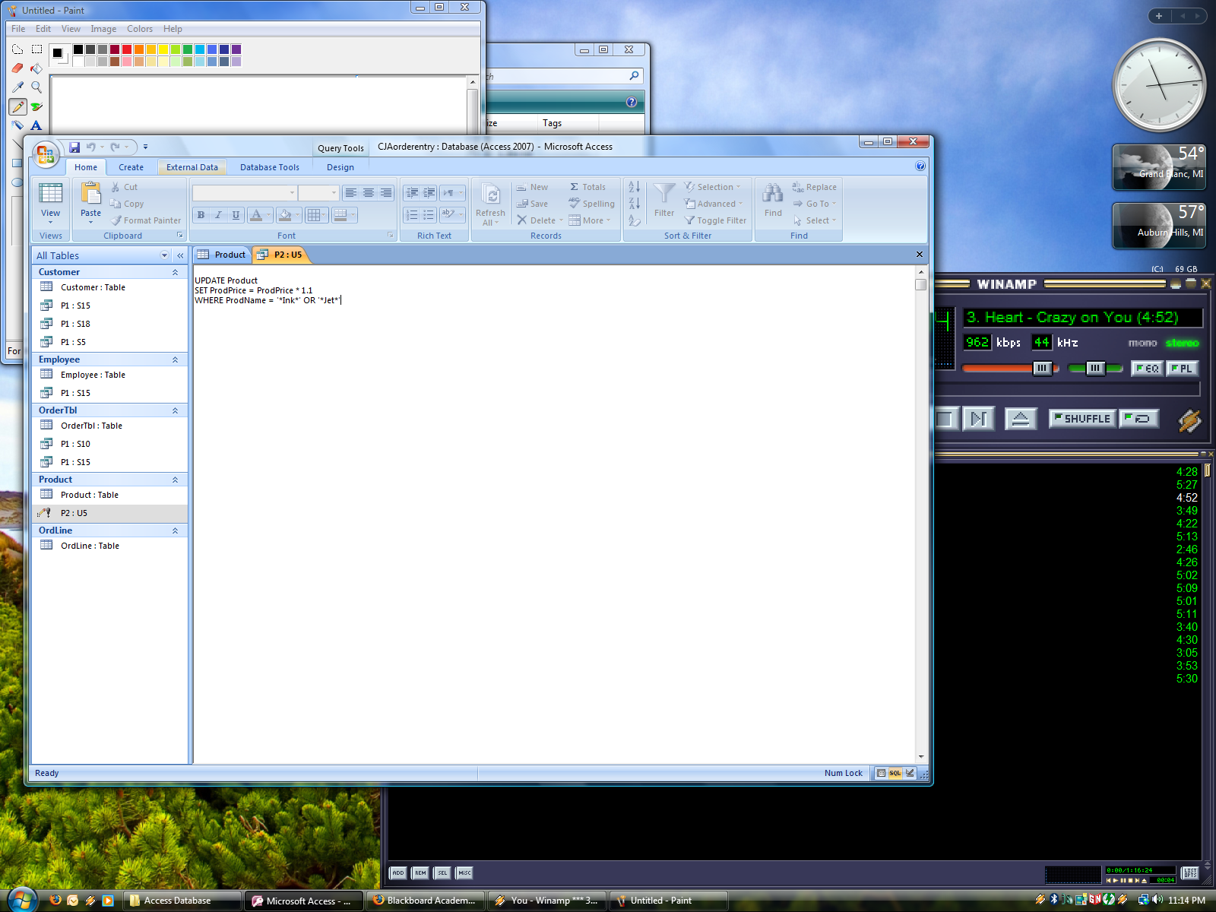

PRODUCT TABLE AFTER UPDATE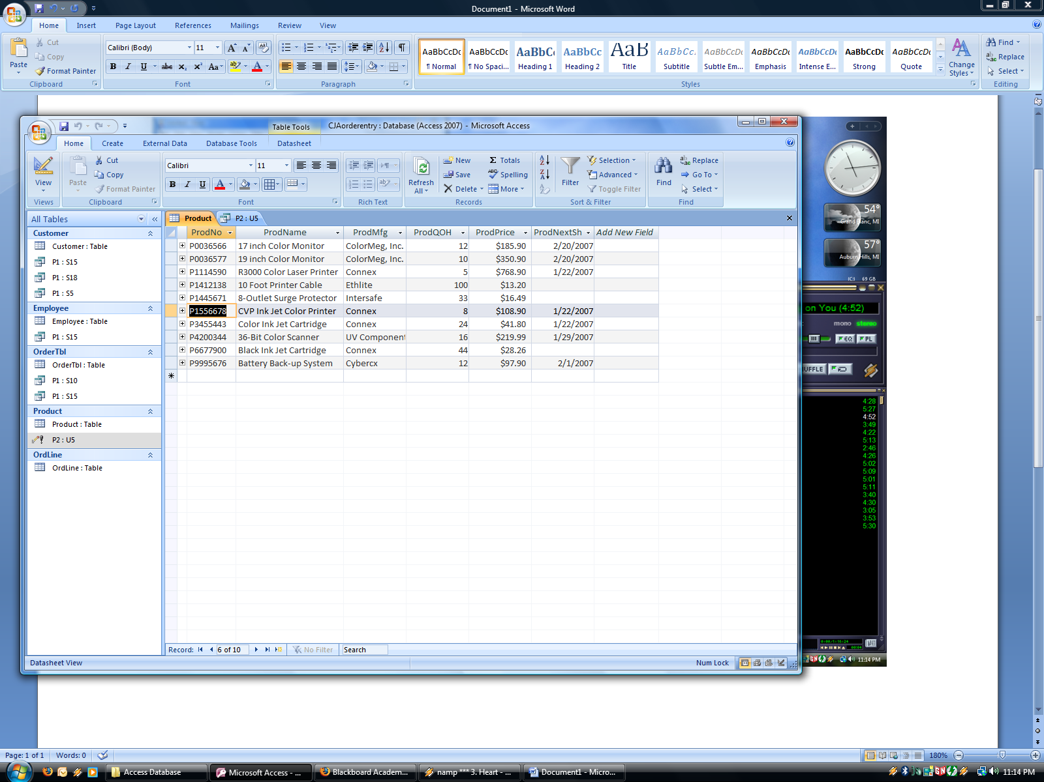

PART 1 SELECT 15 QUERY VIEW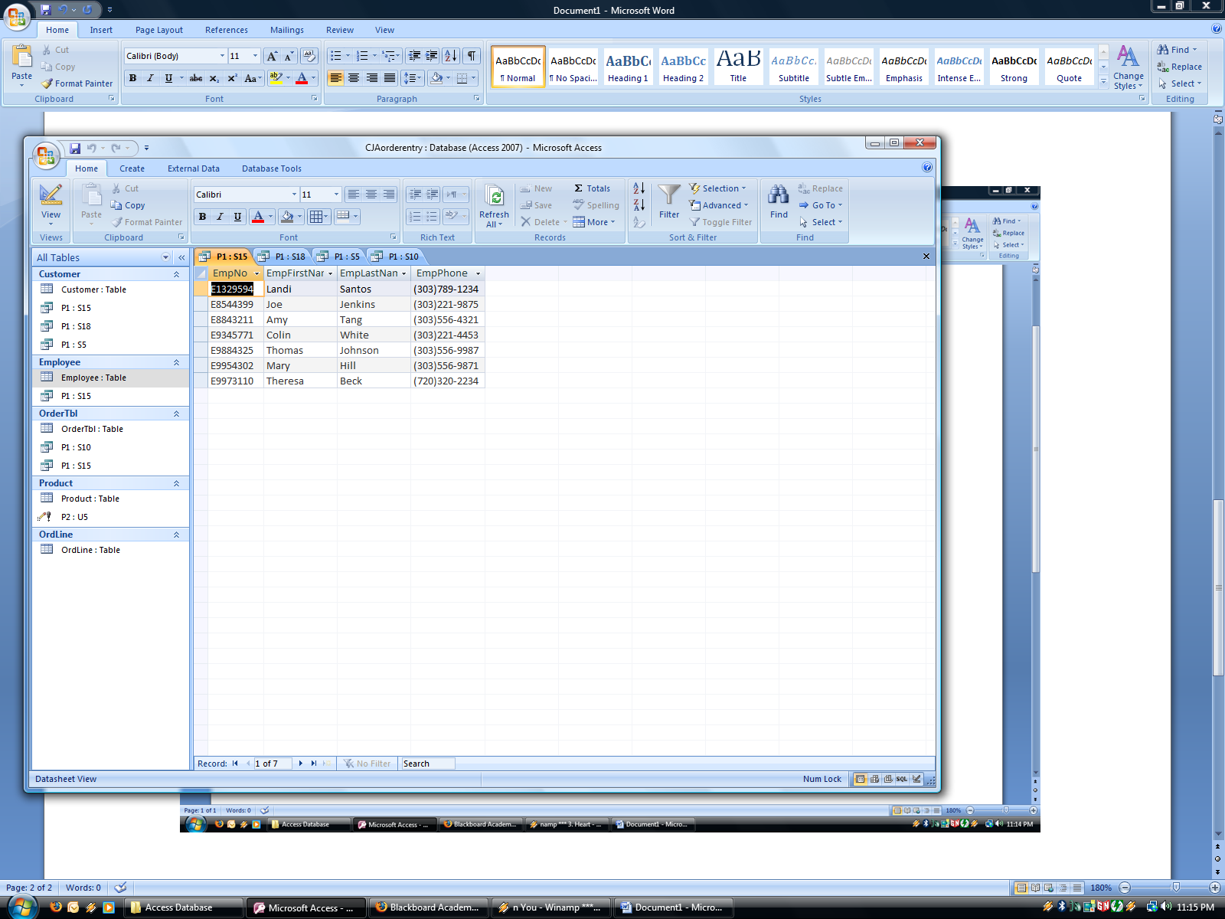

PART 1 SELECT 15 SQL VIEW 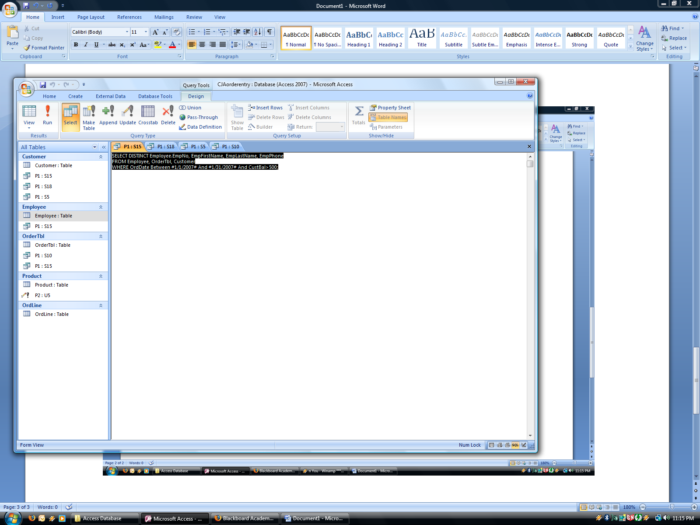

PART 1 SELECT 10 QUERY VIEW 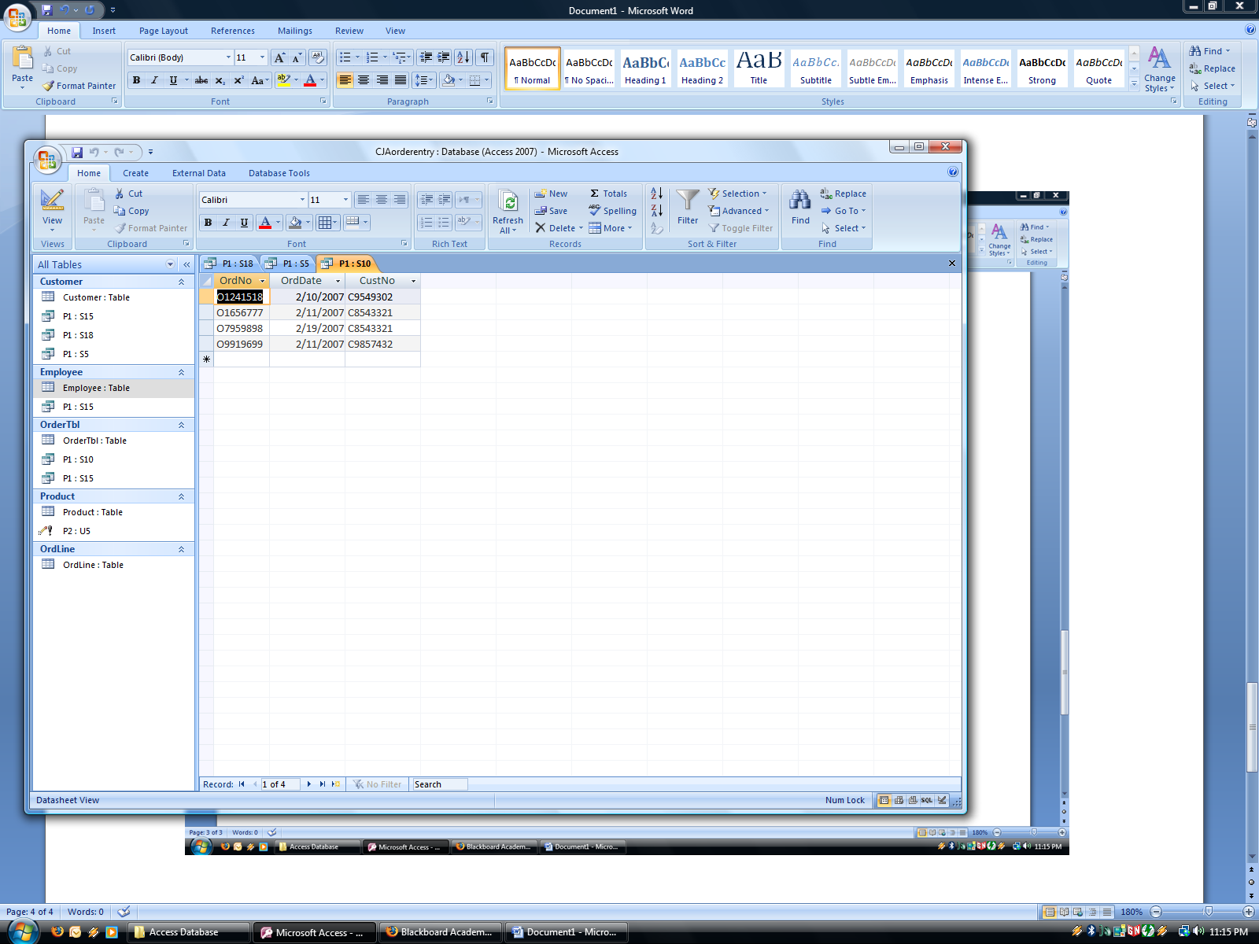

PART 1 SELECT 10 SQL VIEW 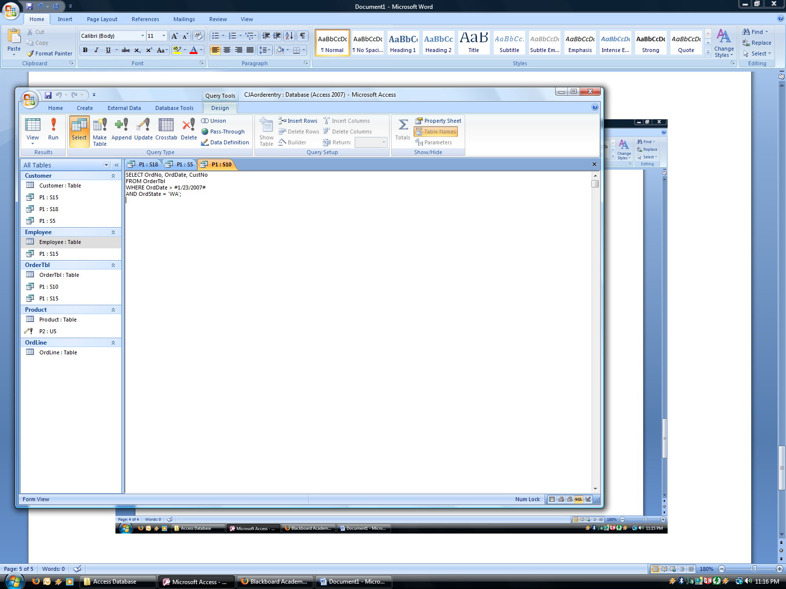

PART 1 SELECT 5 QUERY VIEW 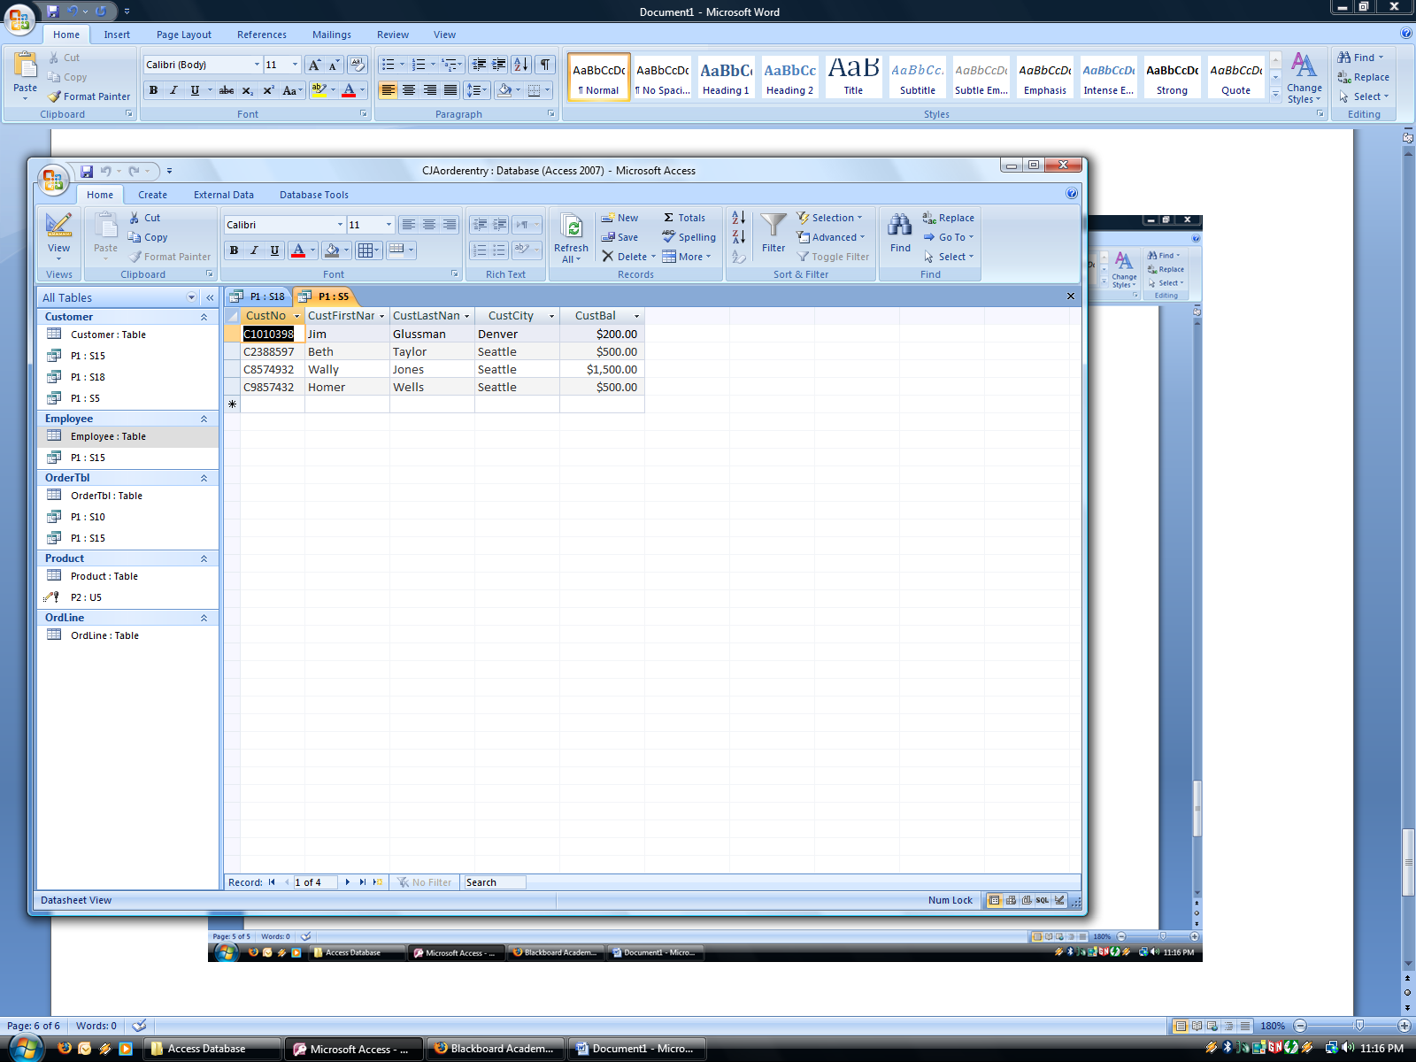

PART 1 SELECT 5 SQL VIEW 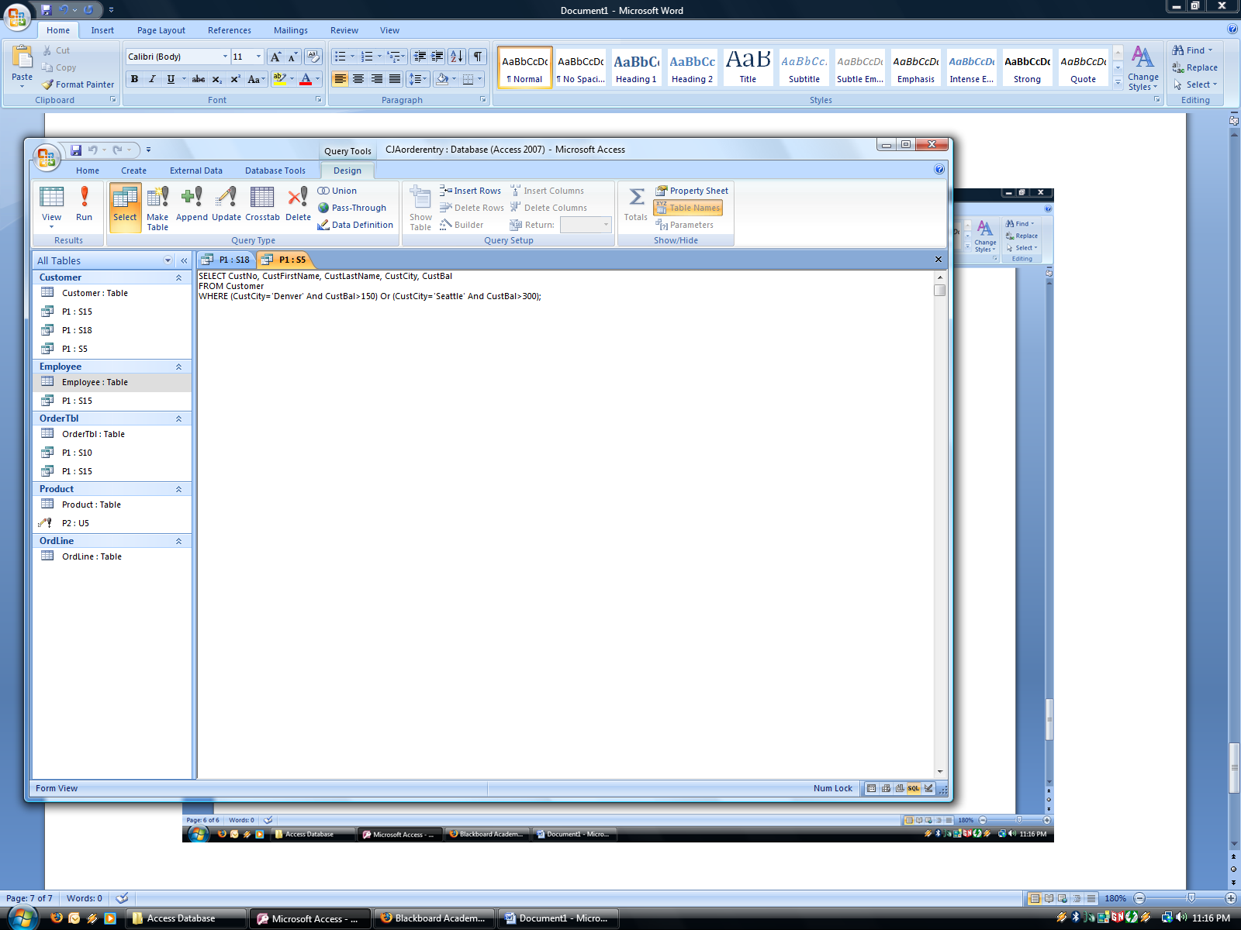

PART 1 SELECT 18 QUERY VIEW 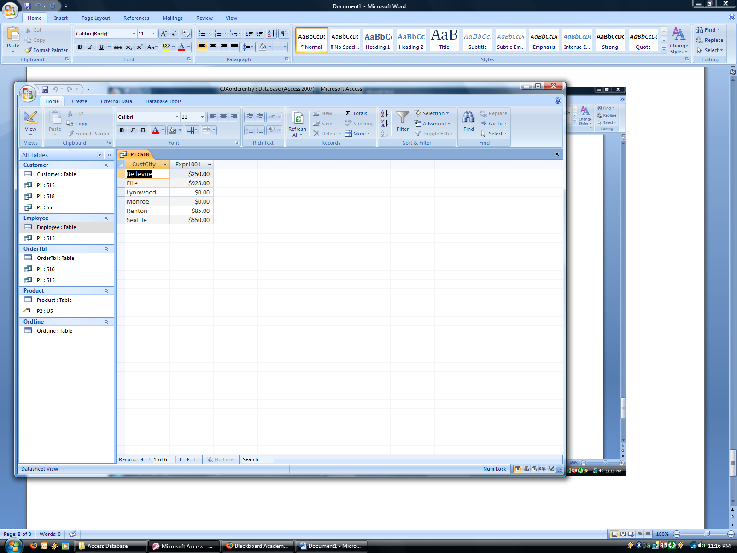

PART 1 SELECT 18 SQL VIEW 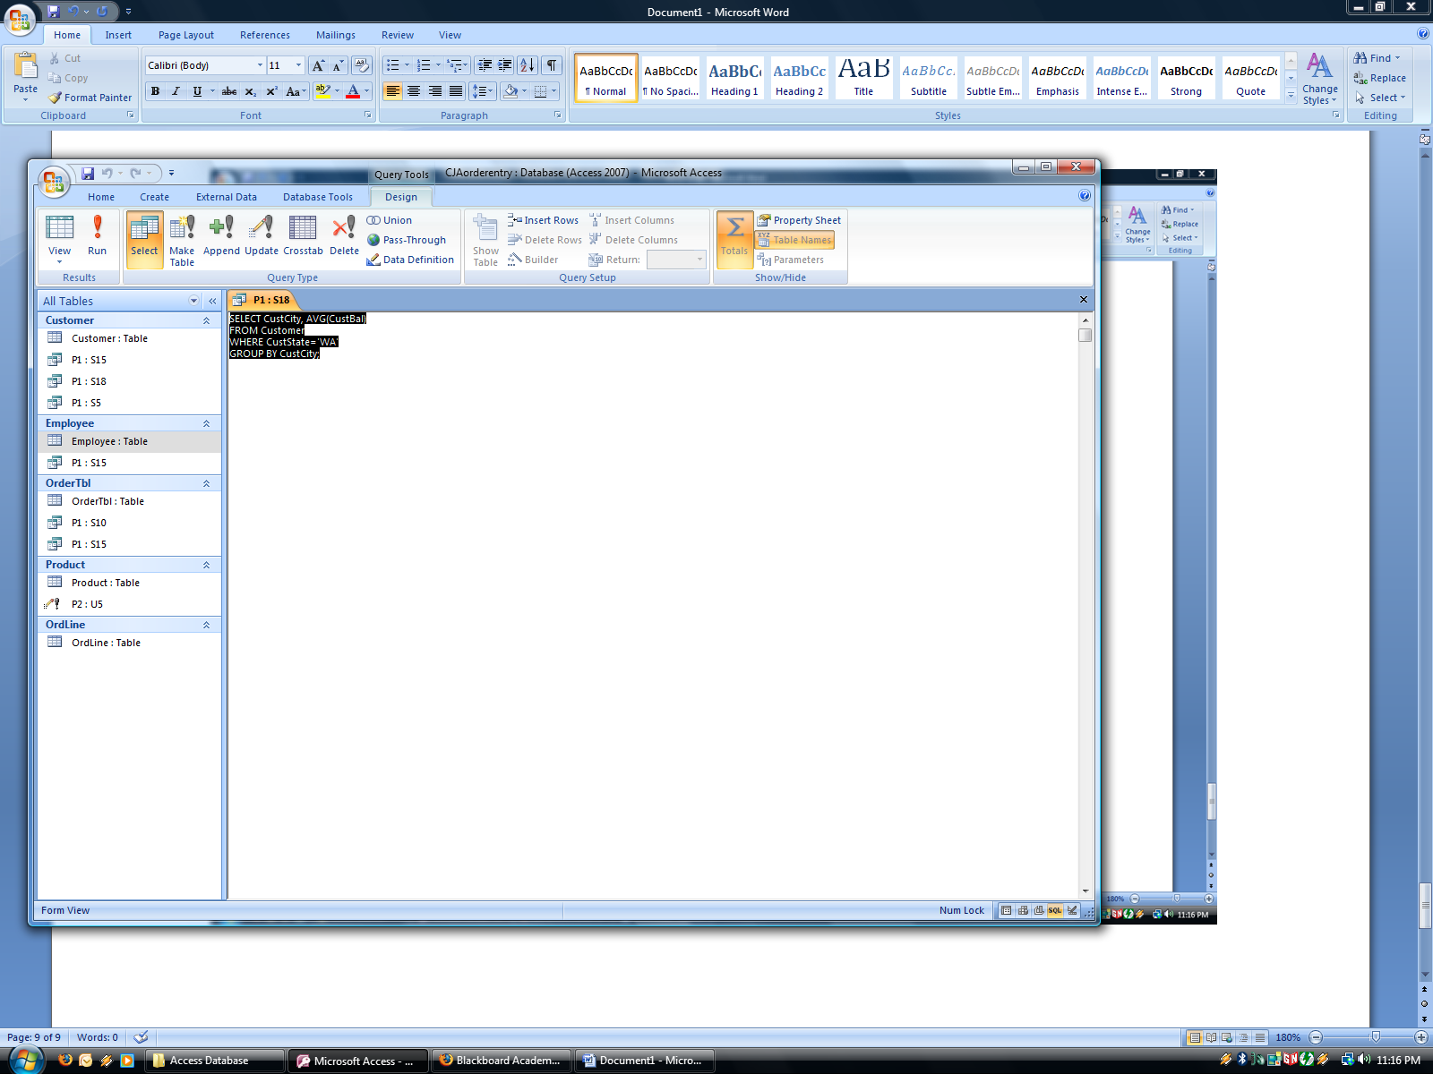

iSQL QUERIES

PART 1 SELECT 15

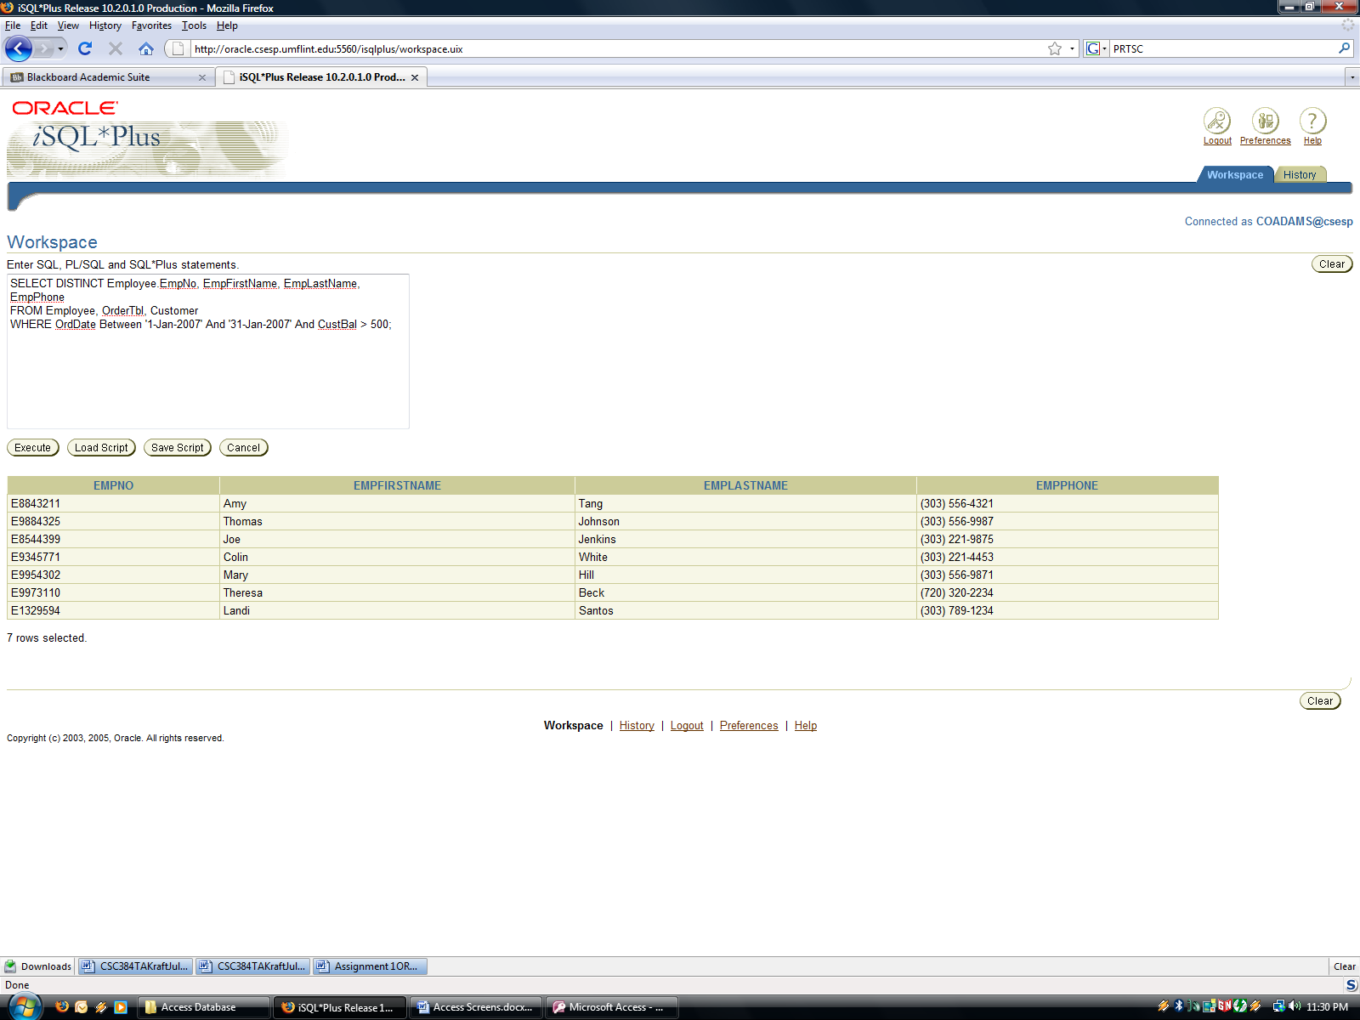

PART 1 SELECT 18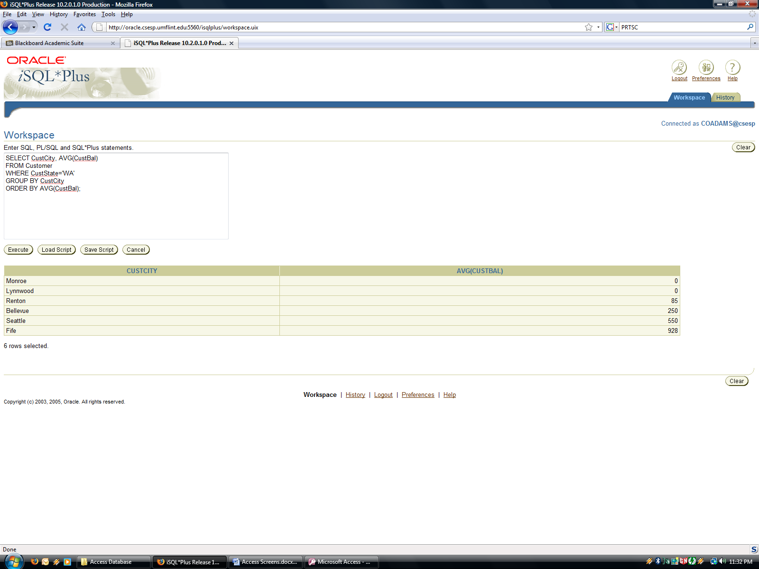

PART 1 SELECT 5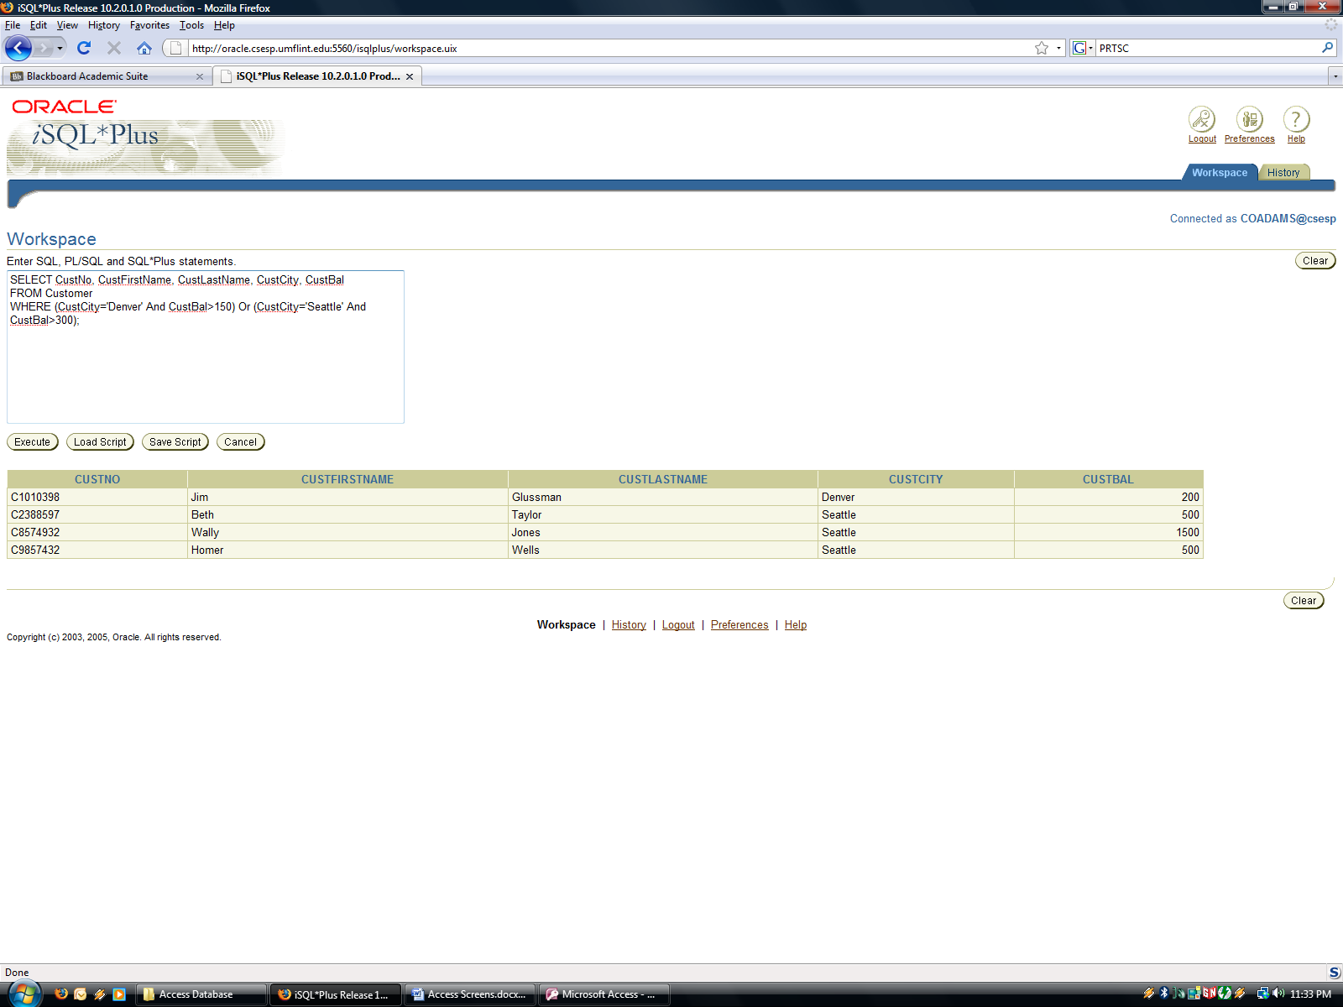

PAER SELECT 10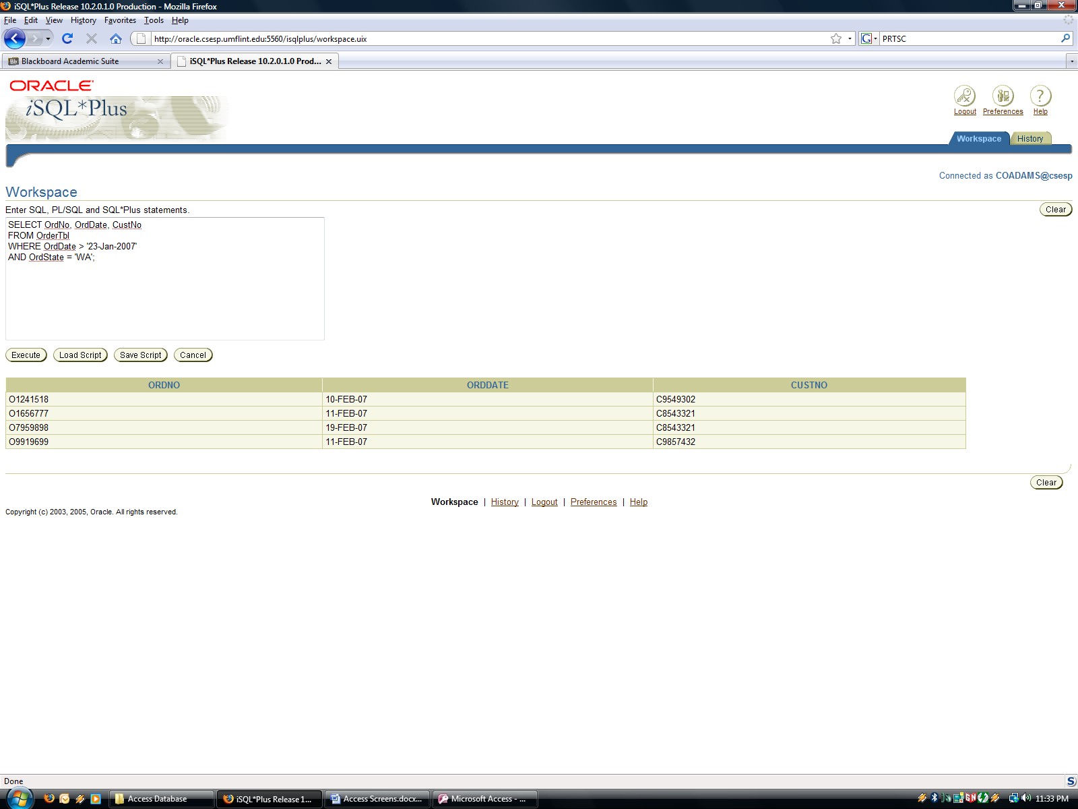

PART 2 UPDATE 5 BEFORE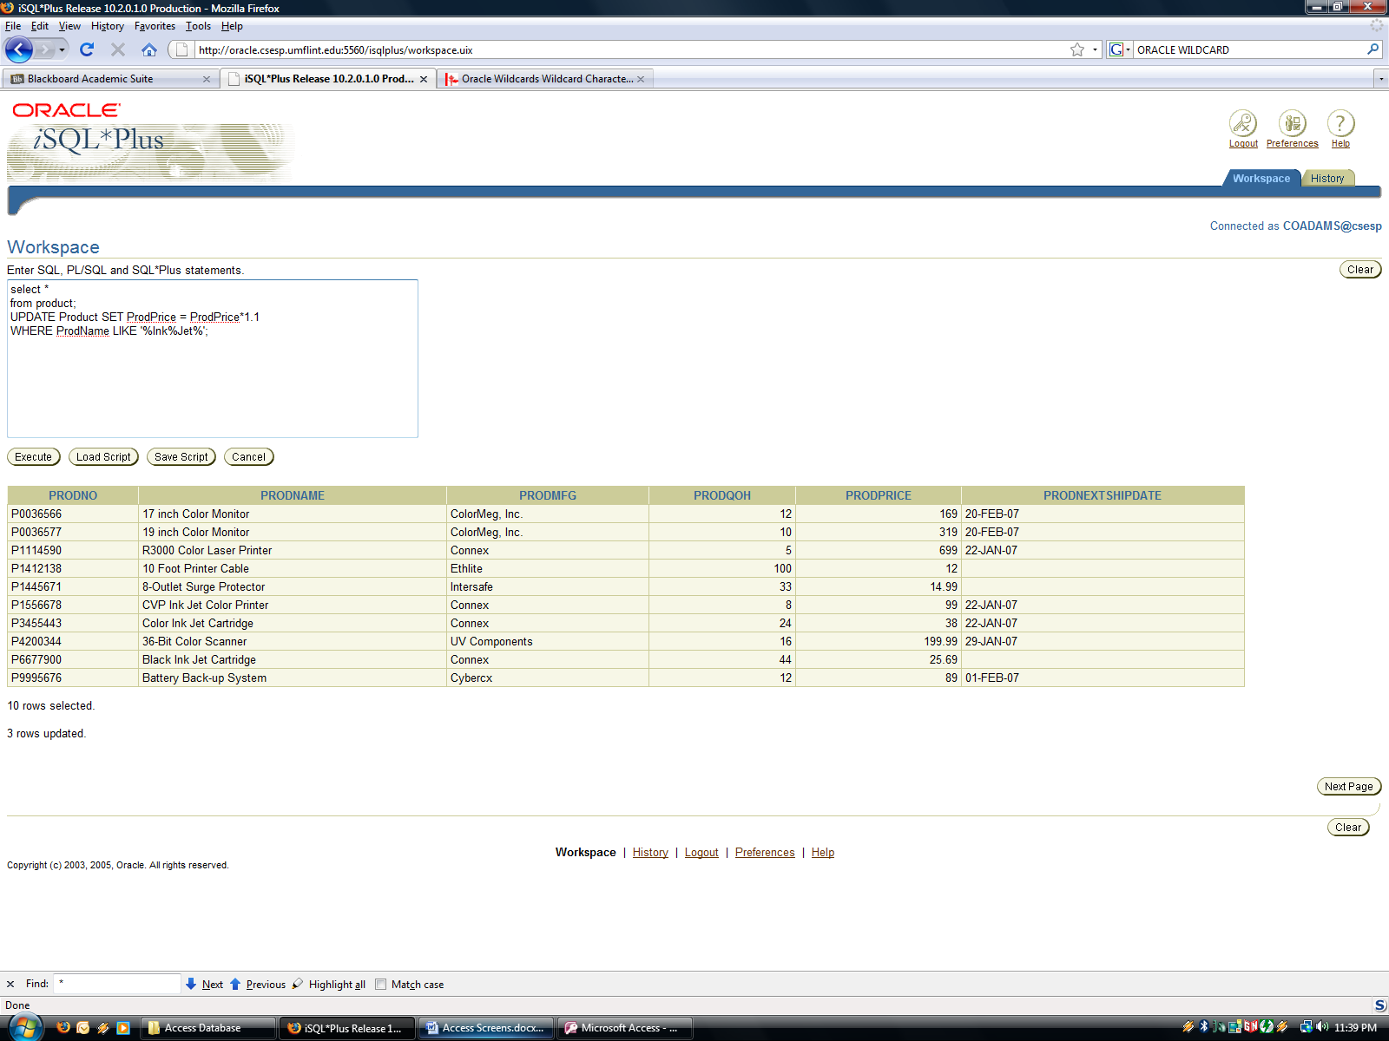

PART 2 UPDATE 5 AFTER